Running head: ATTENTION TO ASSOCIATIVE AND SEMANTIC KNOWLEDGE

Differential Selection of Associative and Semantic Knowledge
during Memory Judgments and Priming
Erin Buchanan
William S. Maki
Department of Psychology, Texas Tech University, Lubbock, TX

Correspondence: Erin Buchanan
University of Mississippi
Department of Psychology
P.O. Box 1848
University, MS 38655
Phone: 662 915-1075
Email: embuchan@olemiss.edu

Abstract
Participants judged pairs of words on the basis of associative or semantic similarity. Associative judgments were not affected by semantic similarity, but semantic judgments were affected by both associative and semantic information. In a second experiment, the to-be-judged words were followed by a perceptual identification task in which the target word was related either semantically or associatively to one of the judged words. Identification was improved (primed) by both associative and semantic relations. Apparently, semantic information was available but ignored when making associative judgments. The results were interpreted in the framework of an extended interactive activation model.

Differential Selection of Associative and Semantic Knowledge
during Memory Judgments and Priming
The relation between associative and semantic knowledge has been the subject of speculation for over a century of experimental psychology. In the 1880s, Trautscholdt distinguished between “outer” associations acquired through frequent environmental co-occurrence and “inner” associations, which included various semantic relationships (Esper, 1973). In modern times, a similar distinction was made by Collins and Loftus (1975) between a lexical network and a semantic network; spreading activation within the semantic network was seen to be the source of semantic facilitation or priming. Fodor (1983) later explicitly localized associative information in the lexical network and allowed a spread of activation among lexical nodes. Although different in particulars, analogous separations of lexical and associative knowledge on one hand and semantic knowledge on the other persist in parallel distributed and interactive activation models of memory (Masson, 1995; Moss, Hare, Day, & Tyler, 1994; Plaut, 1995; Stolz & Besner, 1999).
Investigation of the associative-semantic relation has been aided by recently reported databases containing word association norms (Nelson, McEvoy, & Schreiber, 2004) and semantic feature production norms (McRae, Cree, Seidenberg, & McNorgan, 2005; Vinson & Vigliocco, 2008). The word association norms were obtained using the method of free association in which subjects were asked to produce the first word that comes to mind in response to a cue word. The feature production norms used a similar technique in which subjects were asked to list semantic features that define a given concept. In both cases, a high probability of a response given a cue indicates a strong relationship. These norms are useful in identifying pairs of words that vary along both associative and semantic dimensions. Many people will respond with CAT given the cue DOG, and CAT and DOG share many features (four legs, fur, etc.). Thus DOG and CAT are both associatively and semantically related. The cue ASHTRAY frequently elicits CIGARETTE as a response, but ASHTRAY and CIGARETTE share few semantic features. Thus ASHTRAY and CIGARETTE are associatively, but not semantically related. In contrast, GOAT rarely elicits COW, but GOATs and COWs share many semantic features. Thus, GOAT and COW are related semantically but not associatively. PELICAN and PIER are words that are not highly related on either associative or semantic dimensions.
Beyond such anecdotal observations, the associative and semantic databases allow statistical analyses that also support a separation of associative and semantic knowledge. Maki and Buchanan (2008) compiled a set of 629 word pairs, each having values on 13 measures of word relatedness. A multidimensional scaling analysis showed that associative and semantic variables tended to fall into separate clusters.
The bulk of the experimental evidence on the separation of associative and semantic networks has come from experiments measuring reaction times in the lexical decision task (for recent reviews, see Lucas, 2000, and Hutchison, 2003). In such experiments, reacting to the second of two words is faster when the words are related than when they are not. One of the critical issues has been whether such priming results from associative relatedness or semantic relatedness. The currently available evidence suggests that priming may result from both forms of relatedness (Hutchison, 2003) ¹. The associative and semantic networks, however, appear not to be strictly independent for both theoretical and empirical reasons. The interactive activation model (Stolz & Besner, 1999) has the flow of information in word recognition moving from letter through word to semantic levels. Moreover, semantic priming is amplified when the words are also associatively related (the “associative boost”; Moss et al., 1994).
Thus, the evidence on the separability of associative and semantic knowledge is mixed. Associative and semantic relations combine multiplicatively to determine performance in priming studies, but statistical analyses of available databases suggest that the two forms of knowledge are quite separable. In this paper, we pursue a different approach to the investigation of associative and semantic knowledge. In our experiments, we asked people to judge the relationship between two words. The pairs covaried with respect to the degree of associative and degree of semantic relationship. Judgments were made while under instructions that biased attention toward one type of relationship. If the two forms of knowledge are completely separate, then our judges should have been able to select one kind of information to the exclusion of the other. But if the two forms of knowledge are interdependent, then attentional selection should have been asymmetric and the degree and direction of asymmetry should be informative with respect to the cognitive architecture underlying associative and semantic judgments.
Experiment 1
In previous experiments using a memory judgment task, people rated pairs of words based on the degree of association (Maki, 2007a, 2007b). College students were asked to assign a number to each cue-response pair that indicated how many people out of 100 would be likely to give the response word when prompted with the cue word in a free association task. Maki (2007a) plotted the average values of the judgments of associative memory (JAM) as a function of forward associative strength (FSG; Nelson et al., 2004). The resulting “JAM function” was perfectly linear with a shallow slope and a high intercept. Of interest here is the fact that the JAM function was completely insensitive to semantic distance between words. For example, the word pairs used by Maki (2007b, Experiment 1 transfer phase) varied along both associative and semantic dimensions. Semantic distance was defined as distance between nodes in a hierarchically organized electronic dictionary, WordNet (Fellbaum, 1998). Distance was computed by Maki, McKinley, and Thompson (2004) using the scripts developed by Patwardhan & Pedersen (2003) to calculate the distance measure devised by Jiang and Conrath (“JCN”; 1997). The word pairs were selected on the basis of the JCN values so as to fall into two distinct categories, high similarity (low JCN distance, M = 1.9, range: 0-4.6) and low similarity (high JCN distance, M= 21.7, range: 20.2-24.5). In spite of the extreme difference between semantic distance categories (a factor of over 10), semantic distance had absolutely no effect on associative judgments. For high similarity pairs, JAM = 48.7 + 0.284 FSG, R² = 0.996; for low similarity pairs, JAM = 49.1 + 0.270 FSG, R² = 0.948. One interpretation of these results is that people are able to attend selectively to associative information to the complete exclusion of semantic information. This interpretation is consistent with the view that semantic processing requires attentional resources (Stolz & Besner, 1999). Selectively attending to associative information might then have prevented semantic processing.
The next question is whether attention can be directed to semantic information at the expense of processing associative information. Maki et al. (2004) had people rate the semantic similarity of pairs that differed both in dictionary distance and associative strength. Both semantic and associative dimensions significantly influenced similarity ratings. So it appears that attention can be directed selectively to associative information but associative information cannot be completely ignored.
The foregoing comparisons, however, are confounded by different groups of words, different judgment procedures, and anything else that might contaminate cross-experiment comparisons. Thus, the first experiment described here was designed to eliminate those confounds and thereby provide more solid evidence for the phenomenon of asymmetrical selection of associative and semantic information. People rated pairs of words either on the basis of degree of association or on the basis of semantic relatedness. Both kinds of judgments were made on a common list of word pairs using rating scales that differed only in the instructions distinguishing associative from semantic ratings.
Method
Materials
A random sample of 72 pairs of words was drawn from the Nelson et al. (2004) word association norms. The words in the selected pairs also appeared in the McRae et al. (2005) semantic feature production norms; the pairs all had similarities (cosines) greater than zero. Both the associative strengths (FSG) and the semantic similarities (COS) of the pairs were distributed across the range of values such that some of the pairs fell within each of four categories: x < 0.2, 0.2 < x < 0.4, 0.4 < x < 0.6, and x > 0.6. For FSG, the numbers of pairs within each category were 18, 14, 20, and 20, respectively. For COS, the numbers of pairs were 22, 21, 13, and 16, respectively. The 72 pairs were randomly ordered; both associative and semantic values from each category were represented about equally often in each half of the resulting list.
Two types of general instructions, associative and semantic, were prepared. The associative instructions were identical to those used by Maki (2007a). The instructions described a free association test and contained a demonstration of the free association procedure using the same three cue words used by Maki (2007a). The semantic instructions were identical to those used by Maki, Krimsky, and Munoz (2006). Those instructions emphasized semantic feature overlap as a means of judging semantic similarity and contained a demonstration of semantic similarity ratings using three pairs that were not included in the 72 to-be-rated pairs. Four booklets were prepared. The instructions and demonstrations were printed on the first two pages of each booklet. Each of the remaining three pages was headed by a short paragraph with a reminder about the rating scale to be used followed by the scale itself. For the associative booklets, the reminder was: “Assume 100 college students from around the nation gave responses to each cue word. How many of these 100 students do you think would have given the response word?” The immediately following scale contained 10 categories (0 – 9) corresponding to estimated response frequencies of 0-9, 10-99, …, and 90-100. For the semantic booklets, the reminder was: “Imagine the defining features of both words in each pair and then rate the degree to which the words share those features.” The following scale also contained 10 categories (0-9) and were anchored by “No overlap (different meaning)” and “Complete overlap (same meaning).” The word pairs were listed following the scales on each page. Half the associative booklets and half the semantic booklets contained the original ordering of the 72 pairs; the remaining booklets contained the pairs in reverse order.
Procedure
Participants were tested in small groups, each containing 3-6 students. Each group was randomly assigned to receive either the associative or semantic instructions. Each participant was randomly assigned to receive a booklet containing either the original or reverse ordering of the 72 pairs. At the beginning of each group session, the participants read the general instructions. Then the experimenter reviewed the instructions and led the participants through the demonstration. At the end of the demonstration, the participants revealed their answers by a show of hands and discussed how the answers showed the type of relationship described in their booklets. Then the participants used the scales to rate the 72 pairs of words. Answers were marked on optical scanning forms.
Participants
Fifty-seven undergraduate college students (39 female) were recruited from the Texas Tech University Department of Psychology human subject pool and were compensated for their service by course credit.
Results and Discussion
Associative and semantic ratings were averaged across participants for each of the 72 pairs and were entered into simultaneous multiple regression analyses, one analysis for the associative instructions and a separate analysis for the semantic instructions. For both of the analyses, the predictor variables were the associative strength (FSG) and semantic feature overlap (COS). For the associative analysis, the dependent variable was the associative rating and, for the semantic analysis, the dependent variable was the overlap rating.
The standardized regression coefficients for both analyses are shown in the left panel of Figure 1. Associative ratings were predicted only by associative strength but semantic ratings were predicted by both semantic similarity and associative strength. The associative predictor (FSG) accounted for a significant amount of variance in the associative ratings, β = + 0.68, t = 7.23, p< .001. The semantic predictor (COS), however, was not a significant predictor, β = - 0.07, t = 0.78. In contrast, variations in COS accounted for a significant amount of variation in the semantic ratings, β = + 0.56, t = 6.04, p< .001. Variations in FSG also accounted for a significant amount of variation in the semantic ratings albeit to a lesser extent, β = + 0.24, t = 2.64, p< .01.
Additional evidence for the asymmetrical attention effect comes from a retrospective analysis of data reported by Maki (2007b, Experiment 1). Two groups of participants rated a common set of 90 pairs of words for either their associative or semantic relatedness. The “associative-varied” group received instructions similar to the associative group in this experiment. The “semantic-varied” group received instructions emphasizing semantic similarity. The 90 pairs varied considerably in associative strength (FSG) and also varied in semantic similarity (dictionary distance measured by JCN). The results of the regression analyses are shown in the right panel of Figure 1. Once again, the associative ratings were predicted only by associative strength but the semantic ratings were predicted by both associative strength and semantic similarity. The associative predictor (again FSG) accounted for significant variance in the associative ratings, β = + 0.54, t = 5.79, p< .001, but the semantic variable (JCN) was not a significant predictor, β = + 0.11, t = 1.20. For the semantic ratings, however, JCN was a significant predictor β = - 0.36, t = 3.75, p< .001, and so was FSG, β = + 0.23, t = 2.42, p< .02. Thus the patterns of results in both the present experiment and the retrospective analysis were identical.
These results indicate that there are differential effects of making associative and semantic judgments. The word pairs in this experiment were created so that the pairs could be judged on either associative or semantic information; both types of information were present in both judgment conditions. However, it appears that participants used semantic information only if given semantic instructions. Participants apparently were able to ignore semantic information while making associative judgments. In contrast, associative information was always used when making judgments regardless of the type of instructions. In addition, the differential selection of associative and semantic knowledge generalizes across measures; semantic feature overlap was the measure used in this experiment but dictionary distance was the measure used by Maki et al. (2004).
Experiment 2
The present Experiment 1, together with previous results cited earlier (Maki, 2007a, 2007b; Maki et al., 2004), establishes the asymmetry in attending to associative and semantic information as a robust phenomenon. Apparently, selectively attending to associative information during memory judgments blocks use of semantic information (but not vice versa). But we do not know whether the locus of this blocking of semantic information is early or late during the cognitive processes engaged by the judgment task. The blocking effect could arise early in processing if selective attention to associative information prevents activation of semantic features. The effect could occur later in processing if semantic information is activated and available but ignored when judging associative strength. The experimental task then is to determine whether semantic information survives associative processing. If it does, then we would conclude that the locus of the blocking effect is relatively late in the sequence of processes leading to an associative judgment.
The persistence of semantic information beyond stimulus presentation has been investigated mainly with the use of priming tasks. In the general case, two words are presented sequentially. If the first (prime) word is semantically related to the second (target) word, then both the speed and accuracy of identifying the second word are increased (see Hutchison, 2004, for a review). In this experiment, we created a variation on the priming task appropriate for assessing the persistence of semantic information beyond the act of making a memory judgment. We used the rapid serial visual presentation (RSVP) technique that has been shown to be sensitive to semantic and associative relations among words (e.g., Davenport and Potter, 2005; Maki, Frigen, & Paulsen, 1997). In our hybrid task, each trial began with a judgment made on a pair of words that were presented simultaneously; then followed a stream of rapidly presented distractors that contained one target word and the subject was asked to recall the target. In some of these trials, the target was associatively or semantically related to one of the judgment words. In other trials, the target word was not related to either of the judgment words. Based on the previous RSVP research, we expected increased accuracy in recalling the target word when the priming word in the judgment pair was related to the target. The question we asked was whether processing the judgment pair associatively would reduce (or even prevent) semantic priming.
Method
Design
Each trial in the experiment consisted of two parts. The trial began with a pair of words to be judged semantically or associatively. The second part consisted of an RSVP list of distractors that contained one target word; the target word was associatively related, semantically related, or completely unrelated to one of the words in the judgment pair (the priming word). The target word appeared at one of three serial positions in the RSVP list. Thus the complete 2 x 3 x 3 within-subjects design included as factors Judgment Type, Prime-target Relation, and Lag.
Materials
A total of 216 triplets of words were selected using associative (Nelson et al., 2004) and semantic (Maki et al., 2004) databases. Each triplet contained two words used in the judgment phase of each trial. The third word was the target word that appeared in the RSVP stream. One of the judgment words, the prime, was strongly related associatively or semantically to the target word; the other judgment word was not related in any way to the target. The two words in the judgment pairs were modestly related, both associatively and semantically, to each other.
For associative word pairs, the forward association was kept as high as possible, while insuring no backward relationships and keeping the semantic similarity measure very low. The same procedure was used to create semantic word pairs; semantic similarity was kept high, while association was kept low. For example, DEVELOP and CREATE are semantically related but only weakly associatively related; PEANUT and BUTTER are strongly associatively related but weakly semantically related. The 54 associative prime-target pairs were strongly related in the forwards direction (FSG M=0.57) but not in the backwards direction (BSG M=0.01); these associative pairs were only weakly related semantically (JCN M=20.6). The 54 semantic prime-target pairs were strongly related semantically (JCN M=0.19) but weakly related associatively (FSG M=0.02 and BSG M=0.01).
The words in each of the remaining 108 prime-target pairs were not related to each other. These unrelated pairs were created by randomly repairing words in the databases so that these pairs were neither associatively nor semantically related. The unrelated pairs were used as a baseline to evaluate priming and also to control for relatedness proportion, which is the ratio of related pairs to unrelated pairs. This ratio was kept at 0.25 for each of the different pair types or 0.5 for the whole experiment. For example, SAYING and SCALE are neither associatively nor semantically related.
Judgment pairs were created by combining each prime word with another word that was both semantically and associatively related to the prime word. Regardless of the prime-target relation, the words in the judgment pairs were always related, both associatively in the forwards direction (FSG M = 0.10; BSG M = 0.02) and semantically (JCN M = 13.0). Both relationships were allowed because both semantic and associative judgments were made on the same pairs (by different participants). For example, in the triplet ROAR-LION-SCREAM, the judgment pair was ROAR and SCREAM and the prime target pair was ROAR-LION; LION and SCREAM were unrelated.
The 216 triplets were randomly divided into two sets. Each set contained 27 associative prime-target pairs, 27 semantic prime-target pairs, and 54 unrelated pairs. Each participant experienced both sets of word triplets. One set was assigned to the associative judgment condition and the other set was assigned to the semantic judgment condition. These assignments and their ordering within a session were counterbalanced across participants.
For the judgment pairs, a fixation cross was presented in the middle of the screen, and the judgment words were presented with one word (the prime) above the fixation cross and the other word below the fixation cross. These judgment pairs subtended visual angles of 2.00º horizontally and 2.54º vertically from a viewing distance of 45 cm, and individual words subtended visual angles of 2.00 º horizontally and 0.60 º vertically.
Distractors and target words in the RSVP streams were presented at the center of the monitor screen, each for 67 ms; presentations were synchronized with the 75 Hz refresh rate of the color monitors. Distractor stimuli consisted of a random combination of 8 characters drawn from the set of numbers {0-9} and a set of seven symbols {@ # $ % ^ & *}. Like judgment words, distractors and targets also subtended visual angles of 2.00 º horizontally and 0.60 º vertically.

Procedure
At the beginning of each trial, participants were shown the judgment pair but were instructed to withhold the judgment until after the RSVP task. The judgment pair was presented for 1000 ms before the start of the RSVP stream. The RSVP stream always contained 10 items: one target and 9 distractors. The target word was shown after 1, 3, or 6 distractors. After the RSVP stream ended, participants were presented with a prompt to type the target word. After the RSVP word was entered, the judgment pair reappeared with instructions on how to judge the words. The judgments were described as either associative or semantic, using the same instructions as in Experiment 1. The judgment was entered by typing the number (0-9) corresponding to the judgment and pressing the enter key. The next trial then commenced.
Participants
All 36 participants were recruited from the Texas Tech University human subjects’ pool, and all participants received general psychology course credit for their participation. Participants were excluded from the analysis if they performed below 20 percent correct on the RSVP task. Two participants were excluded from this analysis: these two participants performed below 20% correct, usually by typing one of the judgment words instead of the RSVP stream word.

Results and Discussion

Judgments

The asymmetrical judgment effects found in Experiment 1were replicated in this experiment; the semantic measure (JCN) only predicted semantic judgments but the associative measure (FSG) predicted both associative and semantic judgments. Two multiple linear regressions were performed using FSG and JCN as predictors of word pair ratings in the associative and semantic judgment conditions. The beta for each predictor is presented in the left panel of Figure 2. Associative judgments were predicted significantly by FSG (β= +0.247, t = 3.706, p < 0.001), but not by JCN (β = +0.021, t = 0.309). When making semantic judgments, both FSG (β = +0.191, t = 2.901, p < 0.01) and JCN (β = -0.195, t = -2.956, p < 0.01) predicted ratings of these word pairs.
Priming
Accuracy of recalling the target from the RSVP stream was the dependent variable of interest. For both associatively- and semantically-related pairs, priming was defined as the difference between the proportions of correctly identified targets for related and unrelated pairs. The average difference scores are presented in the right panel of Figure 2 separately for both types of priming (associative vs. semantic) and for both types of judgmental instructions (associative vs. semantic). Strong priming effects were found in all conditions, and associatively primed words were reported more frequently than semantically primed words. However, the amount of priming, both associative and semantic, was not influenced by the type of judgment.
The differences were assessed by a 2 X 2 X 3 (word pair relationship by judgment type by lag) repeated measures analysis of variance. The word relationship main effect was significant F(1,33) = 26.379, p < 0.001, η² = .444, which indicated that associative priming, M = 0.354, SE = .038, was stronger than semantic priming, M = 0.249, SE = .024. The other main effects and interactions were not significant, all Fs <1.333. As seen in the right panel of Figure 2, this finding indicates that amount of priming for semantic and associative word pairs was the same for both judgmental conditions as averaged over lag.
Latencies
For each participant, the distribution of judgment latencies was trimmed using a recursive 3 standard deviation elimination method described by Van Selst and Jolicoeur (1994); on average, 3% of the latencies were eliminated for each participant. The remaining latencies were averaged across participants for each judgmental condition for each of the 216 word triplets. Latency differences were found between the semantic and associative judgment conditions, t(215) = 12.680, p < 0.001. Associative judgments, M=3744.92 ms, SE=73.14, were significantly faster than semantic judgments, M=4907.32 ms, SE=79.18.
One possible interpretation of the priming results is that participants did not fully process word pairs before the judgment task and that is why the judgmental asymmetry was not reflected in the priming data. On this account our participants could have ignored the first word pairs because they were not necessary to complete the RSVP task. If this were the case, then priming should not have occurred in the RSVP task. Yet strong associative and semantic priming was found in the RSVP task, which indicates that participants at least processed the first word pair presented. It may still be the case that participants may have processed the judgment words in an unintended manner but that explanation is unlikely because of the replication of these effects in several experiments by Buchanan (2008). The general pattern of effects in those experiments mirrored those reported here: associative processing blocked semantic control of judgments (but not vice versa), associative priming was stronger than semantic priming, the strong associative and semantic priming effects were independent of the judgmental asymmetry, and associative judgments tended to be made faster than semantic judgments. Importantly, in one of Buchanan’s experiments, judgments were completed before the RSVP stream commenced. In that experiment also, the semantic priming effects did not show any influence of associative judgments; priming effects were the same regardless of whether the judgment was completed before or after the RSVP part of the trial.
General Discussion
During a memory judgment task, attending to associative information completely blocks control of judgments by semantic information. However, attending to semantic information fails to block control by associative information. The results of the present Experiments 1 and 2, together with previously noted findings (Maki, 2007a, 2007b; Maki et al., 2004), demonstrate the reliability and generality of this asymmetry; the differential selection has been found with different materials and measures (Experiment 1) and specific task (Experiment 2). Furthermore, the blocking of semantic information by attending to associative information was found in Experiment 2 to be a judgmental phenomenon. Semantic priming was found in a perceptual identification task that occurred after the to-be-judged pair, a fact that indicates that semantic activation survived attention to association. In that experiment, associative priming was greater in magnitude that semantic priming regardless of type of judgment. Finally, associative judgments were made faster than semantic judgments in Experiment 2 even though there was no emphasis placed on speed.
Taken as a whole, our results show that associative information is privileged relative to semantic information. Associations can be selectively attended but not ignored when making similarity judgments, associative relations are more effective in priming word identification, and associative relations are judged more quickly than semantic relations. However, in spite of the associative priority, semantic information survives associative judgments thus localizing selective effects at some point subsequent to semantic activation. In the remaining discussion, we propose an explanation of these findings based on a current model of word identification and priming.
McClelland and Rumelhart’s (1981) Interactive Activation (IA) model, originally used to describe letter and word perception, has been modified to explain priming and word relationships (Stolz & Besner, 1996). In the IA model, letter identification activates words in a lexical level, which holds both phonological and orthographic information (Collins & Loftus, 1975). However, meaning information is stored in a top-most level, which contains semantic features with two-way connections to the words they describe. Priming occurs in these two-way connections. When one word is activated, meaning or features in the semantic store are also activated. The second related word also shares some of the same feature activation, so the flow of meaning information back down to the word level overlaps. The priming word eases access to the target word which quickens word identification.
However, the original IA model does not have a good description of where associative information would be stored. Williams (1996) proposed an “inter-lexical” hypothesis for associative or co-occurrence links, which asserts that associative information is stored at the lexical level (see also Fodor, 1983). Priming from associative relationships occurs at the lexical level because lexical identification automatically activates the links between the words. Semantic priming would contain to work in much of the same way as before: features from the priming word feed back to the word level which makes identification of the target word faster. Also, associative information can not be restricted or blocked when word identification was necessary because that information is stored in the same level. This inability to restrict information because of word identification might explain why more associative priming occurs than semantic priming. Stolz and Besner (1996), along with follow up studies by Brown, Roberts, and Besner (2001), have shown that semantic information can be blocked from flowing back down to the word level from the semantic level. However, for word identification, the associative links must be activated in the modified IA model, which would explain why associative priming is so strong.
The judgment data from these experiments can be explained from this proposed model. This modified IA model would predict that during an associative judgment task, only associative information is important so only the links in the lower-level lexical-associative store are examined when making those judgments. During a semantic judgment task, both associative information and semantic information should be involved in making judgments because the associative links are activated at the lexical level and the semantic links are activated at the higher, semantic level. For associative judgments, activation of the associative links will determine the strength rating of the judgment because activating a word automatically activates their associates. The judgment process is simply to see if the links between those two words are activated and then a judgment can be made. Semantic judgments require more processing because the comparison procedures are different. After activation in the associative level, the semantic level is activated with all the features of the words presented. A judgment is made on the relationship of the two words by comparing how many features overlap between the two semantic stores. This process takes longer than comparing one link between the associative stores, which is why semantic judgments take longer than associative judgments. ²
The foregoing account of our results leaves unresolved one of the issues raised at the beginning of this report, namely the relation between associative and semantic knowledge. Earlier we found that measures of associative and semantic knowledge tended to form two separate clusters in a multidimensional scaling analysis (Maki & Buchanan, 2008). But here we report that associative information can be selectively attended and semantic information ignored, but that semantic information cannot be selectively attended. For our results to have confirmed a complete separation between associative and semantic information, we would have had to have observed (1) exclusive attention to associative information when participants were judging associative relations, and (2) exclusive attention to semantic information when participants were judging semantic relations. In fact, we found (1) but not (2); when judging semantic relations, our participants' judgments were controlled by both semantic and associative information. One way to reconcile our results with those of Maki and Buchanan (2008) is to view the extended interactive activation model in terms of processes recruited by the judgment task. Following Maki and Buchanan (2008), we observe that judging the strength of a relation between two words is quite a different task than identifying single words, choosing among associates, or generating semantic features. All these tasks may recruit different cognitive processes so in some cases measures used in these tasks may appear independent and in other cases they may be related. At present we do not have the extensive database of similarity ratings that would be needed to test that conjecture.
In summary, here we reported experiments in which participants judged either the associative or semantic similarity between words. When judging associatively, semantic relationships were completely ignored. But when judging semantically, judgments were based on both kinds of information. This asymmetry in selection of associative and semantic knowledge appears to be localized in some relatively late stage of processing during judgments because we found semantic priming by to-be-judged words. We adapted the basic architecture of the interactive activation model (Stolz & Besner, 1999; Williams, 1996) as a framework within which to view our results. In the extended IA model, judgmental processes recapitulate those in word identification: during judgments, lexical and associative processing is followed by semantic processing, but semantic processing occurs only to the extent required by the judgment task. The model also admits another of our findings, namely that associative judgments are made faster than are semantic judgments. Ultimately, the phenomenon of differential selection of associative and semantic knowledge must figure into our understanding of what people know about their associative and semantic memories and how they know it.

References
Brown, M.S., Roberts, M.A., & Besner, D. (2001). Semantic processing in visual word recognition: activation blocking in domain specificity. Psychonomic Bulletin and Review, 8, 778-784.
Buchanan, E. (2008). Differential effects of association and semantics on priming and memory judgments. Unpublished doctoral dissertation, Texas Tech University.
Collins, A. M., & Loftus, E. F. (1975). A spreading-activation theory of semantic processing. Psychological Review.,82, 407-428.
Davenport, J., & Potter, M. (2005). The locus of semantic priming in RSVP target search.
Memory & Cognition, 33, 241-248.
Esper, E. A. (1973). Analogy and Association in Linguistics and Psychology. Athens, GA: University of Georgia Press.
Fellbaum, C. (Ed.). (1998). WordNet: An Electronic Lexical Database. Cambridge, MA: The MIT Press. http://www.cogsci.princeton.edu/~wn
Ferrand, L., & New, B. (2003). Semantic and associative priming in the mental lexicon. In P. Bonin (Ed.), Mental Lexicon: Some Words to Talk about Words (pp. 25-43). Hauppauge, NY : Nova Science Publishers.
Fodor, J. A. (1983). The Modularity of Mind: An Essay on Faculty Psychology. Cambridge, MA: The MIT Press.
Hutchison, K. A. (2003). Is semantic priming due to association strength or feature overlap? A microanalytic review. Psychonomic Bulletin & Review, 10, 785-813.
Jiang, J. J., & Conrath, D. W. (1997). Semantic similarity based on corpus statistics and lexical taxonomy. In Proceedings of International Conference Research on Computational Linguistics (ROCLING X), Taiwan.
Lucas, M. (2000). Semantic priming without association: A meta-analytic review. Psychonomic Bulletin & Review, 7, 618-630.
Maki, W. S. (2007a). Judgments of associative memory. Cognitive Psychology, 54, 319-353.
Maki, W. S., (2007b). Separating bias and sensitivity in judgments of associative memory. Journal of Experimental Psychology: Learning, Memory, and Cognition, 33, 231-237.
Maki, W. S., & Buchanan, E. (2008, in press). Latent structure in measures of associative, semantic, and thematic knowledge. Psychonomic Bulletin & Review.
Maki, W., Frigen, K., & Paulson, K. (1997). Associative priming by targets and
distractors during rapid serial visual presentation: Does word meaning survive the
attentional blink? Journal of Experimental Psychology: Human Perception and
Performance, 23, 1014-1034.
Maki, W. S., Krimsky, M., & Muñoz, S. (2006). An efficient method for estimating semantic similarity based on feature overlap: Reliability and validity of semantic feature ratings. Behavior Research Methods, 38, 153-157.
Maki, W. S., McKinley, L. N., & Thompson, A. G. (2004). Semantic distance norms computed from an electronic dictionary (WordNet). Behavior Research Methods, Instruments, & Computers, 36, 421-431.
Masson, M., E., J. (1995). A distributed memory model of semantic priming. Journal of Experimental Psychology: Learning, Memory, and Cognition, 21, 3-23.
McClelland, J., & Rumelhart, D. (1981). An Interactive Activation Model of Context Effects in Letter Perception: Part 1. An Account of Basic Findings. Psychological Review, 88, 375-407.
McRae, K., Cree, G. S., Seidenberg, M. S., & McNorgan, C. (2005). Semantic feature production norms for a large set of living and nonliving things. Behavior Research Methods, 37, 547-559.
Moss, H. E., Hare, M. L., Day, P., &Tyler, L. K. (1994).A distributed memory model of the associative boost in semantic priming. Connection Science, 6, 413-427.
Nelson, D. L., McEvoy, C. L., & Schreiber, T. A. (2004). The University of South Florida free association, rhyme, and word fragment norms. Behavior Research Methods, Instruments, & Computers, 36, 402-407.
Patwardhan, S., & Pedersen, T. (2003), WordNet::Similarity. http://search.cpan.org/dist/WordNet-Similarity/
Plaut, D. C. (1995). Semantic and associative priming in a distributed attractor network. Proceedings of the 17th Annual Conference of the Cognitive Science Society (pp. 37-42). Hillsdale, NJ: Lawrence Erlbaum Associates.
Stolz, J. A., & Besner, D. (1999). On the myth of automatic semantic activation in reading. Current Directions in Psychological Science, 8, 61-65.
Thompson-Schill, S. L., Kurtz, K. J., & Gabrieli, J. D. E. (1998).Effects of semantic and associative relatedness on automatic priming. Journal of Memory and Language, 38, 440-458.
Van Selst, M., & Jolicoeur, P. (1994, August). A solution to the effect of sample size on outlier elimination. The Quarterly Journal of Experimental Psychology A: Human Experimental Psychology, 47, 631-650.
Vinson, D., & Vigliocco, G. (2008). Semantic feature production norms for a large set of objects and events. Behavior Research Methods, 40, 183-190.
Williams, J. N. (1996). Is automatic priming semantic? European Journal of Cognitive. Psychology, 8, 113-161.
Author note
Address correspondence to Erin Buchanan, Department of Psychology, University of Mississippi, Oxford, MS 38655. (email: embuchan@olemiss.edu). W. Maki is now at the University of Arizona (email: wmaki@email.arizona.edu).
Footnotes
- There are reports that priming can be purely associative (e.g., Ferrand & New, 2003) or purely semantic (e.g., Thompson-Schill, Kurtz, & Gabrieli, 1998). The experimental and theoretical disentangling of the representations underlying associative and semantic priming has often been bound to a separate issue, namely whether priming (and semantic access) is automatic. Our experiments are not relevant to the issue of automaticity and so we avoid it.
- Here we assumed that semantic judgments are based on feature overlap. However, the same predictions follow if one assumes that semantic judgments are based on dictionary distance.
Acknowledgments
We thank Ruth Maki for comments on an earlier version of this paper. These experiments were summarized in a poster presented at the Psychonomic Society meeting, Long Beach, November 2007, and at the University of South Florida Festschrift for Douglas L. Nelson, March, 2008. Experiment 2 was part of the Ph. D. dissertation by the first author.
Figure captions
Figure 1. Associative and semantic influences on judgments as a function of type of instructions. The standardized regression coefficient (β) is on the vertical axis. Separate regressions were performed for the associative instruction group and for the semantic instruction group. The predictor variables in each regression were the associative measure, forward strength (FSG), and the semantic measures: feature overlap cosine (COS) in the left panel and dictionary distance (JCN) in the right panel. All the predictors account for significant variance in ratings except for the semantic predictors under associative instructions.
Figure 2.Associative and semantic influences on judgments and priming as a function of type of instructions. On the left, standardized betas from regression analyses of word pair ratings with the associative (FSG) and semantic databases (COS). FSG and COS were used to predict averaged word pair ratings and all predictors significantly account for the variance except for the semantic predictor (COS) in the associative judgment condition. The right panel indicates priming for semantic and associative word pairs in each type of judgment task. Priming was related word pair report rate minus unrelated word pair report rate. All words are primed greater than zero, and associative word pairs are primed greater than semantic word pairs.
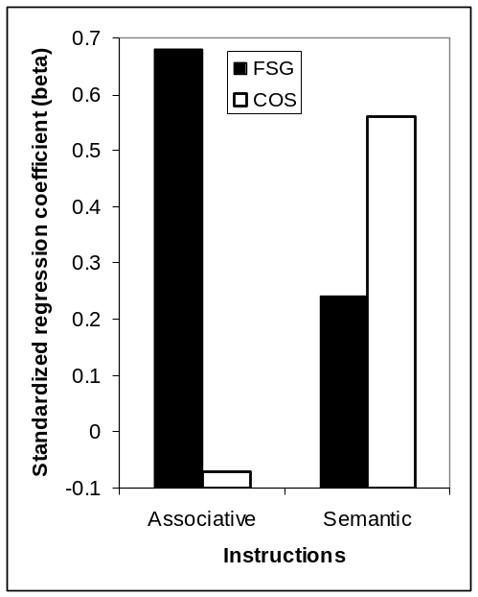 | 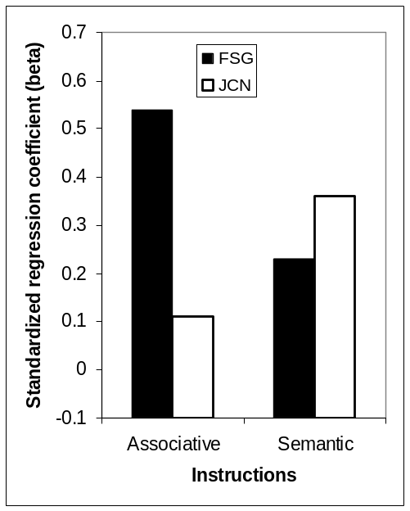

Figure 1

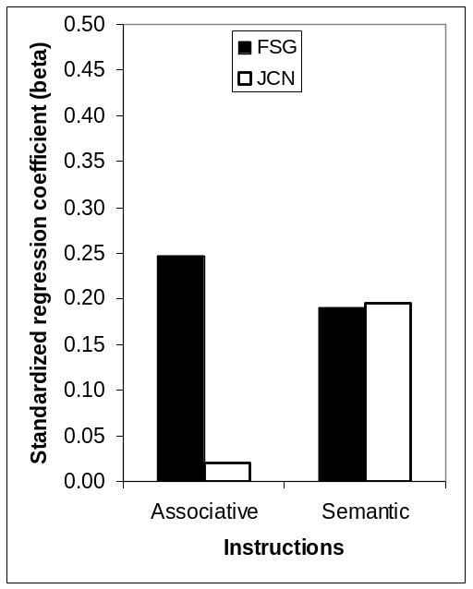 | 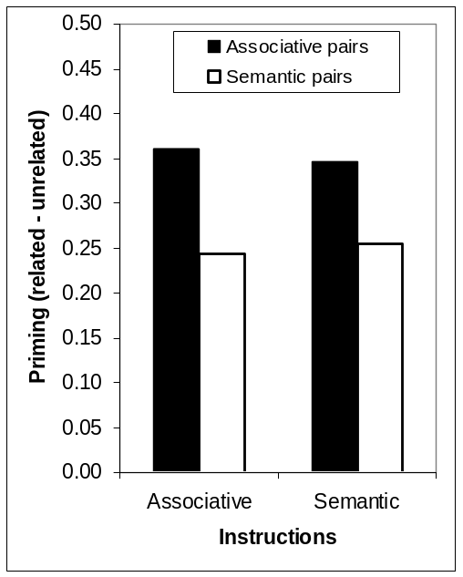

Figure 2

